1. Show all the information on the Avengers.

a. Query: SELECT * FROM avengers

b. Columns: 171

c. Expected row count: 21

1. Create a new table with information from another superhero group [can be imported from elsewhere or fictitious]. Make sure there is an appropriate header and must be at least 30 rows.

Query:

CREATE TABLE TeenTitans(

titan_ID integer not null unique auto_increment primary key,

titan_NAME varchar(40),

dead_NAME varchar(100)

);

INSERT INTO teentitans (titan_NAME, dead_NAME) VALUES ('Robin', 'Richard "Dick" Greyson');

INSERT INTO teentitans (titan_NAME, dead_NAME) VALUES ('DarkStar', 'Donna Troy');

INSERT INTO teentitans (titan_NAME, dead_NAME) VALUES ('Tempest', 'Garth');

INSERT INTO teentitans (titan_NAME, dead_NAME) VALUES ('Arsenal', 'Roy Harper');

INSERT INTO teentitans (titan_NAME, dead_NAME) VALUES ('Kid Flash', 'Wallace Rudolph "Wally" West');

INSERT INTO teentitans (titan_NAME, dead_NAME) VALUES ('Caveboy', 'Gnarrk');

INSERT INTO teentitans (titan_NAME, dead_NAME) VALUES ('Dove', 'Don Hall');

INSERT INTO teentitans (titan_NAME, dead_NAME) VALUES ('Hawk', 'Hank Hall');

INSERT INTO teentitans (titan_NAME, dead_NAME) VALUES ('Herald', 'Malcom Duncan');

INSERT INTO teentitans (titan_NAME, dead_NAME) VALUES ('The Harlequin', 'Duela Dent');

b. Columns: 3

c. Expected row count:

1. Add a column to your new table (let us call it the new superheros) for those who are interested in joining the Avengers. Make this be randomly assigned.  ***Hint:****it is okay for this to be a multi-step query.  You will have to use rand() function and CASE WHEN statement too.*

a. Query: UPDATE teentitans SET join_avengers = CASE WHEN RAND() < .3 THEN 'yes' ELSE 'no' END;

b. Columns: 4

c. Expected row count: 40

d. Screenshot

1. Add a column to your new table (the new superheros) for their favorite Avenger (have it randomly choose between  Anthony Edward "Tony" Stark,  Robert Bruce Banner, & Victor Shade).

a. Query: CREATE TEMPORARY TABLE FAVORITE(AVENGER VARCHAR(40));

INSERT INTO FAVORITE(AVENGER) value('Anthony Edward "Tony" Stark');

INSERT INTO FAVORITE(AVENGER) value('Robert Bruce Banner');

INSERT INTO FAVORITE(AVENGER) value('Victor Shade');

update teentitans set fav_avenger = (select avenger from favorite order by rand() limit 1);

DROP temporary TABLE FAVORITE;

SELECT * FROM TeenTitans;

b. Columns: 5

c. Expected row count: 40

d. Screenshot

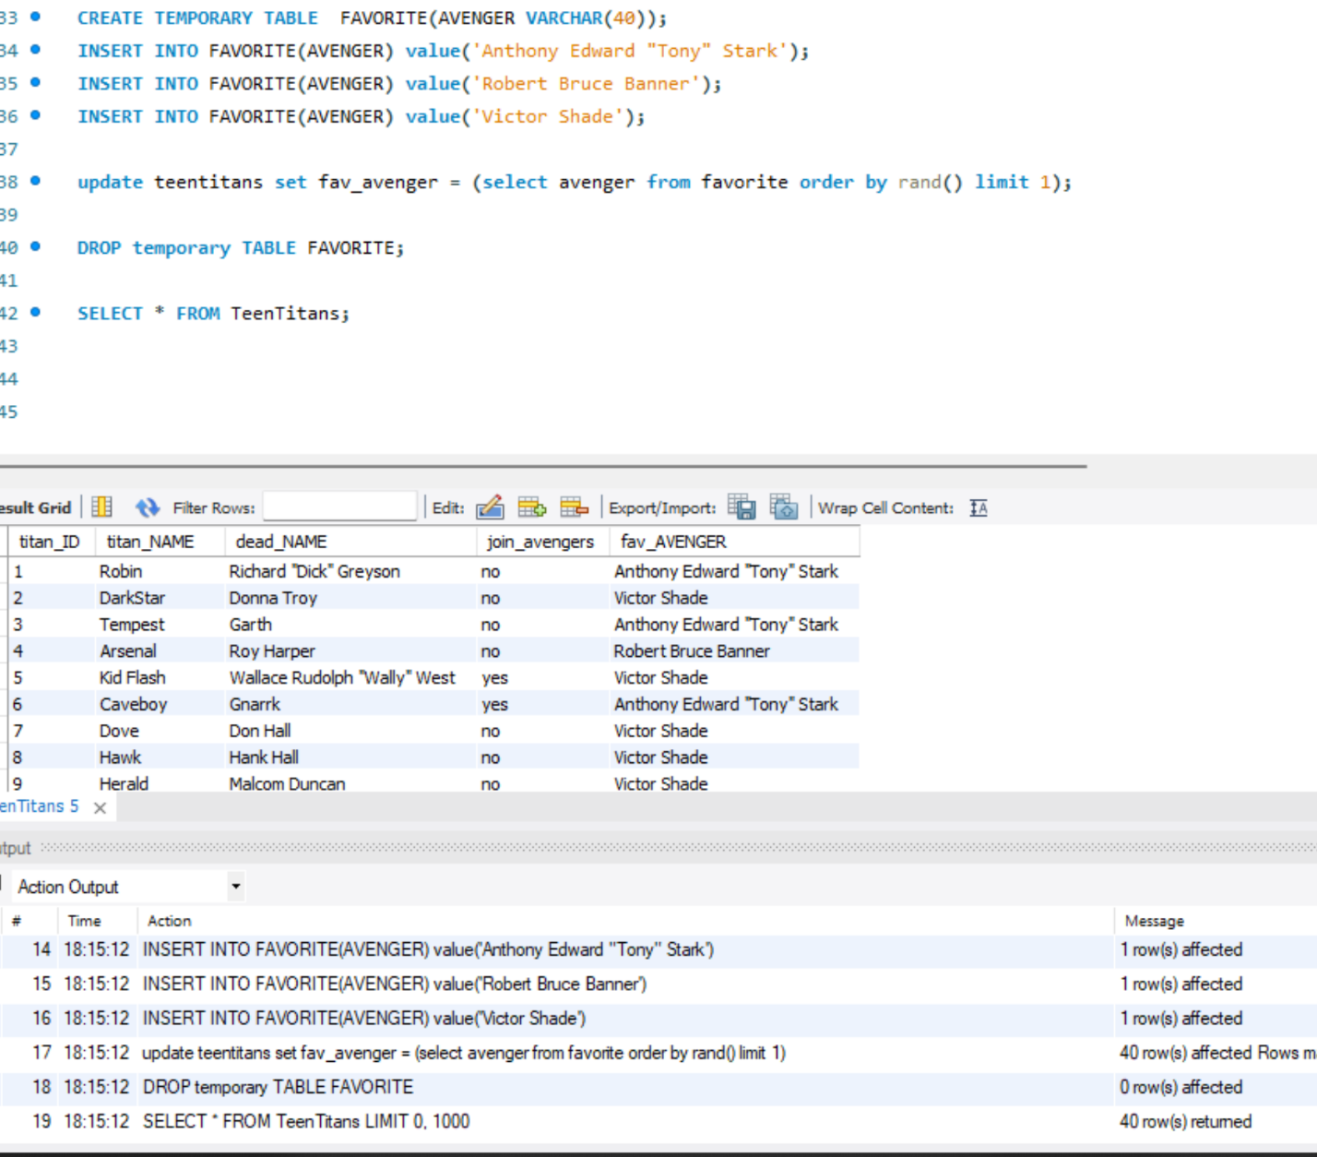

1. Use a JOIN statement between the two tables for who is interested in joining the Avengers.

a. Query: SELECT name as 'Avenger', titan_name as 'TeenTitan', fav_avenger as 'Favorite' FROM teentitans

LEFT JOIN avengers ON teentitans.fav_avenger = avengers.name

where teentitans.join_avengers = 'yes';

b. Columns: 3

c. Expected row count: 9

1. List all Avengers who have more than 1000 appearances in alphabetic order.

a. Query: select name, appearances from avengers where appearances > 1000

order by name;

b. Columns: 2

c. Expected row count: 20

d. Screenshot

1. What Avengers do not have more than 1000 appearances?

a. Query: select name, appearances from avengers where appearances < 1000;

b. Columns: 2

c. Expected row count: 151

d. Screenshot

1. Not more than 500?

a. Query: select name, appearances from avengers where appearances < 500;

b. Columns: 2

c. Expected row count: 128

d. Screenshot

1. Not more than 50 and female?

a. Query: select name, appearances, gender from avengers where appearances < 50 and gender = 'female';

b. Columns: 3

c. Expected row count: 18

d. Screenshot

1. More than 150, male, and are full members?

a. Query: select name, appearances, gender, honorary from avengers where appearances > 150 and gender = 'male' and honorary = 'full';

b. Columns: 4

c. Expected row count: 51

d. Screenshot

